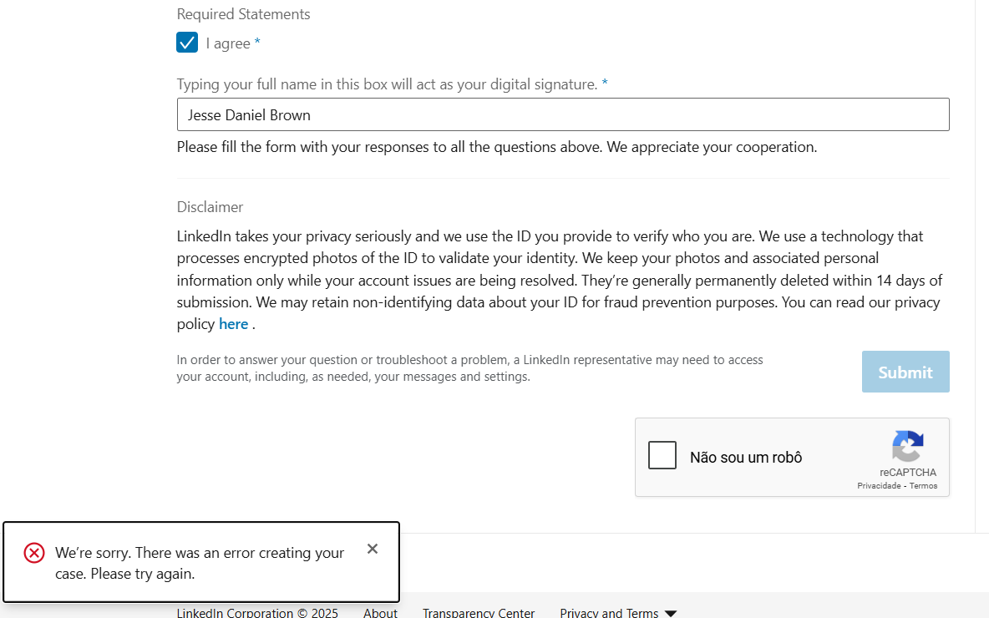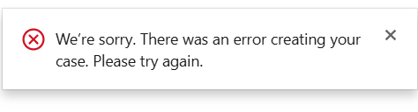Contact LinkedIn support

Account Verification Questions
First Name *This field is required.
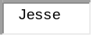
Last Name *This field is required.
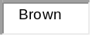
Email *This field is required.
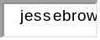
Does the name of your LinkedIn Profile match the name on your Photo ID? *This field is required.
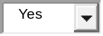
Are you currently traveling/have you accessed your account from another country (i.e. traveling, business trip, etc.)? *This field is required.
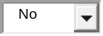
Have you created/accessed your account through a VPN (Virtual Private Network) or Proxy Server? *This field is required.
Please specify your current location/country. *This field is required.
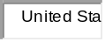
Did you make recent updates to your profile after creating it? *This field is required.
If you believe your account has been restricted incorrectly, tell us why we need to relook at our decision. Please make your request as detailed as possible. *This field is required.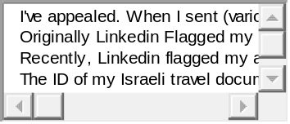
Attach a copy of your ID *This field is required.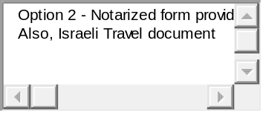
- Affidavit-of-Identity-Form-US.pdf1.14 MBRemove attachment 0
- 20251006_140516.jpg4.41 MBRemove attachment 1
- 20251006_140500.jpg4.37 MBRemove attachment 2
- 20251006_140522.jpg4.42 MBRemove attachment 3
- Linkedin apology.docx40.62 KBRemove attachment 4
- Linkedin account resctriction removed.docx92.44 KBRemove attachment 5
- Linkedin is ignoring my messages.docx58.68 KBRemove attachment 6
- Copy of live chat with linkedin premium help service.docx92.44 KBRemove attachment 7
Add an attachment
Required Statements
- 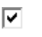I agree *This field is required.
Typing your full name in this box will act as your digital signature. *This field is required.
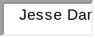
Please fill the form with your responses to all the questions above. We appreciate your cooperation.
Disclaimer
LinkedIn takes your privacy seriously and we use the ID you provide to verify who you are. We use a technology that processes encrypted photos of the ID to validate your identity. We keep your photos and associated personal information only while your account issues are being resolved. They’re generally permanently deleted within 14 days of submission. We may retain non-identifying data about your ID for fraud prevention purposes. You can read our privacy policy here .
In order to answer your question or troubleshoot a problem, a LinkedIn representative may need to access your account, including, as needed, your messages and settings.
